ExNo :
Date:
QUICK SORT & HEAP SORT

Write a C++ program to implement the following sorting techniques:
- Quick Sort
- Heap Sort

AIM:
To write and implement C++ programs to sort a given set of n elements in ascending order using Quick Sort and Heap Sort, and display the sorted array.

8.1The program should accept n elements from the user, sort them in ascending order, and display the sorted array.

ALGORITHM:
Step 1: Start the program.
Step 2: Read the number of elements n.
Step 3: Read the n elements into an array.
Step 4: Select the last element as the pivot.
Step 5: Partition the array by placing elements smaller than the pivot on the left side and larger elements on the right side.
Step 6: Place the pivot in its correct position.
Step 7: Recursively apply Quick Sort to the left sub-array.
Step 8: Recursively apply Quick Sort to the right sub-array.
Step 9: Display the sorted array in ascending order.
Step 10: Stop the program.

PROGRAM:

#include <iostream>
using namespace std;

void quickSort(int a[], int low, int high)
{
if (low < high)
{
int pivot = a[high];
int i = low - 1;

for (int j = low; j < high; j++)
{
if (a[j] < pivot)
{
i++;
swap(a[i], a[j]);
}
}

swap(a[i + 1], a[high]);

int p = i + 1;

quickSort(a, low, p - 1);
quickSort(a, p + 1, high);
}
}

int main()
{
int n;
cout << "Enter number of elements: ";
cin >> n;

int a[n];

cout << "Enter elements: ";
for (int i = 0; i < n; i++)
cin >> a[i];

quickSort(a, 0, n - 1);

cout << "Sorted array: ";
for (int i = 0; i < n; i++)
cout << a[i] << " ";

return 0;
}

OUTPUT:
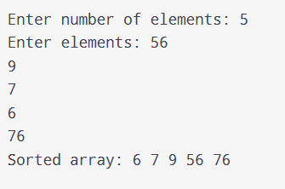

8.2Heap Sort

ALGORITHM:
Step 1: Start the program.
Step 2: Read the number of elements n.
Step 3: Read the n elements into an array.
Step 4: Build a Max Heap from the given array.
Step 5: Swap the root element with the last element of the heap.
Step 6: Reduce the heap size by one.
Step 7: Apply heapify to restore the Max Heap property.
Step 8: Repeat Steps 5–7 until all elements are sorted.
Step 9: Display the sorted array in ascending order.
Step 10: Stop the program.

PROGRAM:

#include <iostream>
using namespace std;

void heapify(int a[], int n, int i)
{
int largest = i;
int left = 2 * i + 1;
int right = 2 * i + 2;

if (left < n && a[left] > a[largest])
largest = left;

if (right < n && a[right] > a[largest])
largest = right;

if (largest != i)
{
swap(a[i], a[largest]);
heapify(a, n, largest);
}
}

void heapSort(int a[], int n)
{
// Build max heap
for (int i = n / 2 - 1; i >= 0; i--)
heapify(a, n, i);

// Extract elements
for (int i = n - 1; i > 0; i--)
{
swap(a[0], a[i]);
heapify(a, i, 0);
}
}

int main()
{
int n;
cout << "Enter number of elements: ";
cin >> n;

int a[n];

cout << "Enter elements: ";
for (int i = 0; i < n; i++)
cin >> a[i];

heapSort(a, n);

cout << "Sorted array: ";
for (int i = 0; i < n; i++)
cout << a[i] << " ";

return 0;
}
OUTPUT:
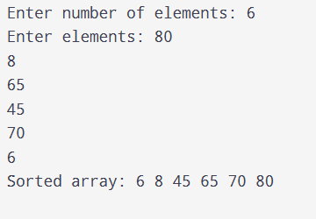

RESULT:
Thus, the C++ programs for Quick Sort and Heap Sort were successfully implemented, and the given elements were sorted and displayed in ascending order.

ExNo :
Date:
BINARY SEARCH & HASHING

AIM
To write and implement C++ programs to search for an element using Binary Search in a sorted array and to store elements in a hash table using the Division Method with linear probing.

9.1Write a C++ program to implement Binary Search. The program should accept n sorted elements and a key element, then search for the key using Binary Search and display its position.

ALGORITHM:
Step 1: Start the program.
Step 2: Read the number of elements n.
Step 3: Read the n elements in sorted order.
Step 4: Read the key element to be searched.
Step 5: Initialize low = 0 and high = n - 1.
Step 6: Calculate the middle position using mid = (low + high) / 2.
Step 7: Compare the key with the middle element.
Step 8: If the key is equal to the middle element, display its position.
Step 9: If the key is smaller, set high = mid - 1; otherwise, set low = mid + 1.
Step 10: Repeat Steps 6–9 until the element is found or low > high.
Step 11: If the element is not found, display an appropriate message.
Step 12: Stop the program.

PROGRAM:

#include <iostream>
using namespace std;

int main()
{
int n, key, low, high, mid;

cout << "Enter number of elements: ";
cin >> n;

int a[n];

cout << "Enter sorted elements: ";
for (int i = 0; i < n; i++)
cin >> a[i];

cout << "Enter element to search: ";
cin >> key;

low = 0;
high = n - 1;

while (low <= high)
{
mid = (low + high) / 2;

if (a[mid] == key)
{
cout << "Element found at position " << mid + 1;
return 0;
}
else if (key < a[mid])
high = mid - 1;
else
low = mid + 1;
}

cout << "Element not found";

return 0;
}
OUTPUT:
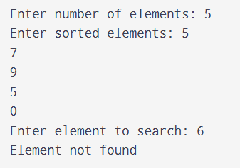

9.2 Write a C++ program to implement Hashing using the Division Method. Insert n elements into a hash table and display the hash table.

ALGORITHM:
Step 1: Start the program.
Step 2: Read the size of the hash table.
Step 3: Initialize all hash table positions as empty.
Step 4: Read the number of elements n.
Step 5: Read each element one by one.
Step 6: Calculate the hash index using the division method: index = key % size.
Step 7: Check whether the calculated position is empty.
Step 8: If the position is occupied, use linear probing to find the next available position.
Step 9: Insert the element into the available position.
Step 10: Repeat Steps 5–9 for all elements.
Step 11: Display the hash table with its index and stored elements.
Step 12: Stop the program.

PROGRAM:

#include <iostream>
using namespace std;
int main()
{
int n, size, key, index;

cout << "Enter hash table size: ";
cin >> size;

int hashTable[size];

for (int i = 0; i < size; i++)
hashTable[i] = -1;

cout << "Enter number of elements: ";
cin >> n;

cout << "Enter elements: ";

for (int i = 0; i < n; i++)
{
cin >> key;

index = key % size;

while (hashTable[index] != -1)
{
index = (index + 1) % size;
}

hashTable[index] = key;
}

cout << "\nHash Table:\n";

for (int i = 0; i < size; i++)
{
cout << i << " --> ";

if (hashTable[i] == -1)
cout << "Empty";
else
cout << hashTable[i];

cout << endl;
}
return 0;
}
OUTPUT:
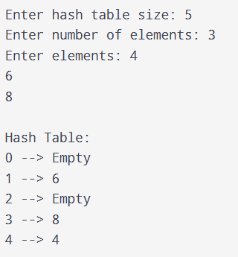
RESULT:
Thus, the C++ programs for Binary Search and Hashing using the Division Method were successfully implemented, and the required search result and hash table were displayed.

